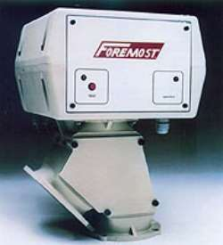
One (1) Foremost Model SEP-GA-4 Metal Separator per drawing
Y-2542-137-4, for the detection of ferrous and non-ferrous metal particles in free falling material. This unit comes with 110 volt, single phase voltage. Each unit comes complete with a 4” diameter inlet, a sensing ring, air operated diverter chute, self contained electrical controls, a bottom flange, a discharge adaptor and three feet of flex hose with hose clamps. The smallest detectable part is 1.3mm FE and the flow-through capacity is 243cu/ft. per hour at 35lbs cu.ft. 60 to 80 PSI clean, unlubricated compressed air is required,
(Customer to supply)

* Flo-thru capacity is based on a 1/8” virgin pellet with a bulk density of 35 lbs/cu.ft.

PRICE…$6,397.00
OPTIONAL:
1. Conical feed hopper (aluminum) $ 781.00
2. Adaptor for mounting cyclone $ 507.00
- Aluminum pedestal with filter, to allow the mounting of a vacuum chamber
(Additional support may be required by customer) $ 1,483.00
4. Dual counter analyzer (reject & contamination count) $ 2,306.00
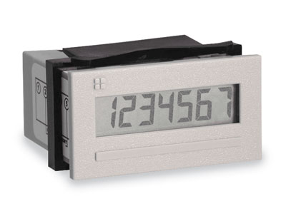

5. Filter regulator #M-AA-20 $ 101.00
6. Flap into reject as soon as air or power supply fail $ 1,127.00
7. Plastic drum w/dolly & flexible filter cover to accept rejected contaminants $ 396.00
8. High wear ceramic product tube for abrasive materials $ 995.00

Shipment: Currently 4-6 weeks A.R.O., subject to production backlog at time of order, F.O.B. point of origin, Freight collect

